ABSTRACT

All articles must contain an abstract.The abstract text should be formatted using 12 point Times or Times New Roman. Leave 10 mm space after the abstract before you begin the main text of your article, starting on the same page as the abstract. The abstract should give readers concise information about the content of the article and indicate the main results obtained and conclusions drawn. The abstract is not part of the text and should be complete in itself; no table numbers, figure numbers, references or displayed mathematical expressions should be included. It should be suitable for direct inclusion in abstracting services and should not normally exceed 200 words in a single paragraph. Since contemporary information-retrieval systems rely heavily on the content of titles and abstracts to identify relevant articles in literature searches, great care should be taken in constructing both.

Keywords: Keywords 1, Keywords 2, Keywords 3, Keywords 4, Keywords 5

List of notations
v is the allowable vertical displacement
α is the coefficient of thermal expansion of concrete
T2 is the slab bottom surface temperature
T1 is the slab top surface temperature
L is the length of the longer span of the slab
l is the length of the shorter span of the slab
h is the effective depth of the slab, as given in BS EN1994-1-2
fy is reinforcement yield stress
E is the elastic modulus of the reinforcement

1.0 INTRODUCTION
A concise, accurate, but not exhaustive, summary of current knowledge, with reference to relevant previous and recent works in the field should be presented. This should be accompanied with the aims of and justification for the work contained in the submitted manuscript.
The methods and processes applied to investigate and achieve the aims should be communicated in sufficient detail that readers could repeat the work successfully (Lim et al., 2018). The results should be reported clearly and logically, must be interpreted accurately and discussed fairly. Figures/tables can be used to support these findings but data must not be reproduced in more than one form. It is a requirement that all research articles include a section at the end of the main text that highlights the contribution of the findings to the field and any potential applications (Chuah et al., 2018).
These guidelines show the best layout for your paper using Microsoft Word. It is vital that you do not add any headers, footers or page numbers to your paper; these will be added during the production process at publishing (this is why the Header and Footer margins are set to 0 cm in Table 1).

2.0 SECTIONS, SUBSECTIONS AND SUBSUBSECTIONS
The use of sections to divide the text of the paper is optional and left as a decision for the author. Where the author wishes to divide the paper into sections the formatting shown in Table 1 should be used.

Style and spacing

Table 1. Formatting sections, subsections and subsubsections.

Font Spacing

Section 12 point Times bold 1 line space before a section
No additional space after a section heading
Subsection 12 point Times bold 1 line space before a subsection
No space after a subsubsection heading

Numbering
Sections should be numbered with a dot following the number and then separated by a single space:
    - sections should be numbered 1.0, 2.0, 3.0, etc
    - subsections should be numbered 2.1, 2.2, 2.3, etc
    - subsubsections should be numbered 2.3.1, 2.3.2, etc

3.0 FOOTNOTES
Footnotes should be avoided whenever possible. If required they should be used only for brief notes that do not fit conveniently into the text.

4.0 FIGURES
Each figure should have a brief caption describing it and, if necessary, a key to interpret the various lines and symbols on the figure.

Space considerations
Authors should try to make economical use of the space on the page; for example:
    - avoid excessively large white space borders around your graphics;

    - try to design illustrations that make good use of the available space—avoid unnecessarily large amounts of white space within the graphic;

Text in figures
Wherever possible try to ensure that the size of the text in your figures (apart from superscripts/subscripts) is approximately the same size as the main text (12 points).

Line thickness
In general, try to avoid extremely fine lines (often called ‘hairline’ thickness) because such lines often do not reproduce well when printed out—your diagrams may lose vital information when downloaded and printed by other researchers. Try to ensure that lines are no thinner than 0.25 pt. Note that some illustrations may reduce line thickness when the graphic is imported and reduced in size (scaled down) inside Microsoft Word.

Colour illustrations
You are free to use colour illustration, but any print version will only be printed in black and white unless special arrangements have been made with your conference organiser for colour printing. Please check with the conference organiser whether or not this is the case. If any print version will be black and white only, you should check your figure captions carefully and remove any reference to colour in the illustration and text. In addition, some colour figures will degrade or suffer loss of information when converted to black and white and this should be taken into account when preparing them.

Positioning figures
Individual figures should normally be centred but place two figures side-by-side if they will fit comfortably like this as it saves space. Place the figure as close as possible after the point where it is first referenced in the text. If there are a large number of figures it might be necessary to place some before their text citation. Figures should never appear within or after the reference list.

Figure captions/numbering
Captions should be below the figure and separated from it by a distance of 6 points—although to save space it is acceptable to put the caption next to the figure. Figures should be numbered sequentially through the text—‘Figure 1’, ‘Figure 2’ and so forth and should be referenced in the text as ‘Figure 1’, ‘Figure 2’,… and not ‘fig. 1’, ‘fig. 2’, ….
For captions not placed at the side of the figure, captions should be set to the width of the figure for wider figures, centred across the width of the figure, or, for narrow figures with wide captions, slightly extended beyond the width of the figure. The caption should finish with a full stop (period).


Figure 1. Figure with short caption (caption centred).


Figure 2. In this case simply justify the caption so that it is as the same width as the graphic.

Figures in parts
If a figure has parts these should be labelled as (a), (b), (c) etc on the actual figure. Parts should not have separate captions.

5.0 TABLES
Note that as a general principle, for large tables font sizes can be reduced to make the table fit on a page or fit to the width of the text. Because tables can take many forms, it is difficult to provide detailed guidelines; however, the following examples demonstrate our preferred styles.

Positioning tables
Tables should be centred unless they occupy the full width of the text.

Tables in parts
If a table is divided into parts these should be labelled (a), (b), (c) etc but there should only be one caption for the whole table, not separate ones for each part.

Table captions/numbering
Tables should be numbered sequentially throughout the text and referred to in the text by number (Table 1, not tab. 1 etc). Captions should be placed at the top of the table and should have a full stop (period) at the end. Except for very narrow tables with a wide caption (see examples below) the caption should be the same width as the table.

Rules in tables
Tables should have only horizontal rules and no vertical ones. Generally, only three rules should be used: one at the top of the table, one at the bottom, and one to separate the entries from the column headings. Table rules should be 0.5 points wide.

Examples of tables
The following is a slightly more complex table with a caption that is narrower than the table. Centre the caption across the width of the table. If it is difficult to make a table fit the page, use a smaller font. Headings should normally have an initial capital and normally align left (but centred sometimes looks better); it is up to the author to choose a layout that is most useful to the reader. Columns of numbers normally align on the decimal point.

Table 2. A slightly more complex table with a narrow caption.

 | Wake Chi Sqr. (N=15,  df=1) | p | Stage 1 Chi Sqr. (N=15,  df=1) | p | Stage 2 Chi Sqr. (N=15,  df=1) | p
F3 | 1.143 | 0.285 | 0.286 | 0.593 | 0.286 | 0.593
Fz | 1.143 | 0.285 | 0.067 | 0.796 | 0.067 | 0.796
C4 | 2.571 | 0.109 | 0.600 | 0.439 | 1.667 | 0.197

Table 3. A slightly more complex table with a caption that is the same width as the table. Justify the caption.

 | Wake Chi Sqr. (N=15,  df=1) | p | Stage 1 Chi Sqr. (N=15,  df=1) | p | Stage 2 Chi Sqr. (N=15,  df=1) | p
F3 | 1.143 | 0.285 | 0.286 | 0.593 | 0.286 | 0.593
Fz | 1.143 | 0.285 | 0.067 | 0.796 | 0.067 | 0.796
Cz | 1.143 | 0.285 | 0.077 | 0.782 | 0.286 | 0.593

6.0 Notes to tables
If you wish to format a table so that it contains notes (table footnotes) to the entries within the body of the table and/or within the table caption, these notes should be formatted using alphabetic superscripts such as ª, ^{b}, ^{c} and so forth. Notes within the table caption should be listed first. Notes should be placed at the bottom of the table; one convenient method is to create an empty row at the bottom of the table to contain them. Again, merge the cells to give you a single cell the width of the table. Table notes should be 10 point Times Roman. Each note should be on a separate line.

Table 4. A table with headings spanning two columns and containing notesa.

Thickness
Separation energies

Nucleus (mg cm^{–2}) | Composition | γ, n (MeV) | γ, 2n (MeV)
¹⁸¹Ta 19.3±0.1^{b} | Natural | 7.6 | 14.2
²⁰⁸Pb 3.8±0.8 | 99% enriched | 7.4 | 14.1
²⁰⁹Bi 2.6±0.01 | Natural | 7.5 | 14.4
ªNotes are referenced using alpha superscripts.
^{b}Self-supporting.

7.0 EQUATIONS AND MATHEMATICS
Make sure that your Equation Editor or MathType fonts, including sizes, are set up to match the text of your document.

Alignment of mathematics
The preferred style for displayed mathematics is to centre equations; however, long equations that will not fit on one line, or need to be continued on subsequent lines, should start flush left. Any continuation lines in such equations should be indented by 25 mm.
Equations should be split at mathematically sound points, often immediately before =, + or
– signs or between terms multiplied together. The connecting signs are not repeated and appear only at the beginning of the turned-over line. A multiplication sign should be added to the start of turned-over lines where the break is between two multiplied terms.
Small displayed equations: Some examples:
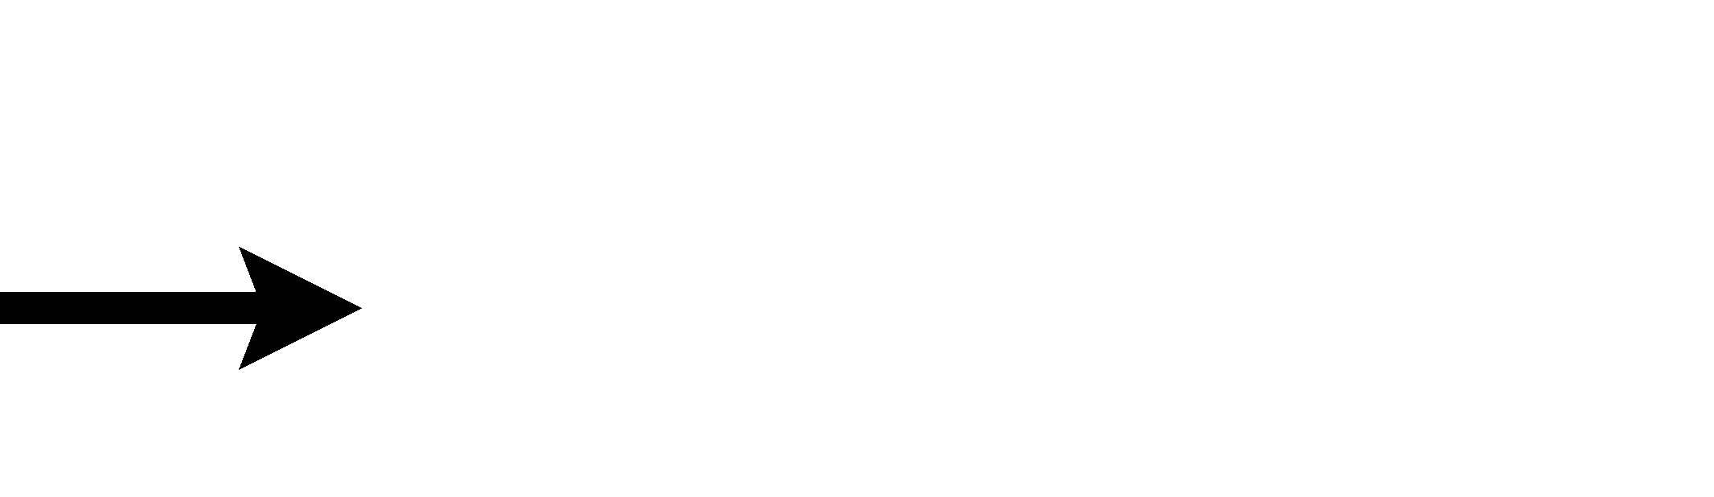
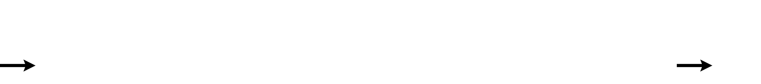
φ(r) = (2π)2 3 exp (ik ⋅ r )

k
2

A(3 2) = A(+) − A(−)
However, if equations will fit on one line, do so:

(I = ³ )
(1)

(2)

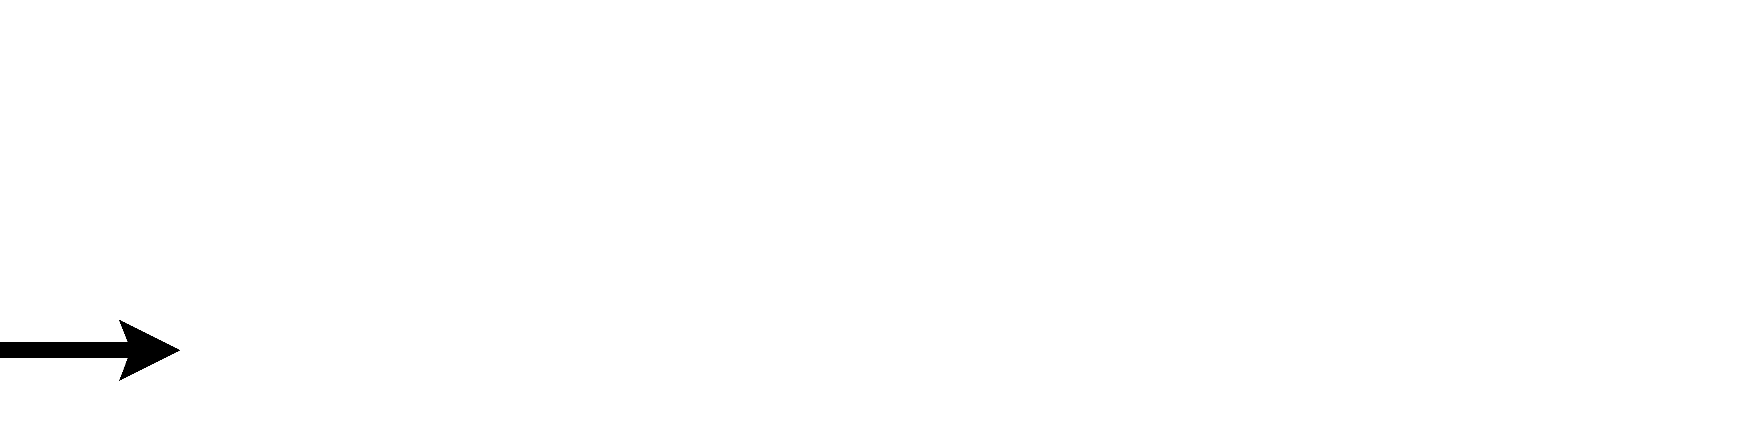

⎡ ⎤ r² ^{L} xdx
≈ 1 − const ln
r2
L2
⎛ L ⎞ +
⎜⎝ r ⎟⎠
L
x

C (12) = ⎣π( x) ⋅φ( x + r)⎦ ≈ 1 − const 2 ∫ 2 +
r
(3)

Large display equations: examples. If an equation is almost the width of a line, place it flush left against the margin to allow room for the equation number.

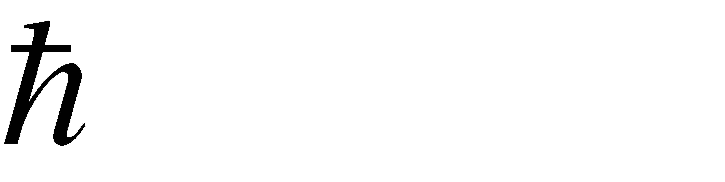
Y (hν) =
q [(hν )² − (hν)² ]² + ( Δω )² (hν)²
r
1 2
1 (hν)²
∫ [E + (Ev
− hν)] 2
1
1
∞
v
E dE

Equation numbering
Eτ−EV −Δϕ[E + (E
- E−
)] 2 exp[(E − Em ) kT ] + 1
(4)

Equations may be numbered sequentially throughout the text (i.e., (1), (2), (3),…) or numbered by section (i.e., (1.1), (1.2), (2.1) ,…) depending on the author’s personal preference. In articles with several appendices equation numbering by section is useful in the appendices even when sequential numbering has been used throughout the main body of the text: for example, A.1,
A.2 and so forth. When referring to an equation in the text, always put the equation number in brackets—e.g. ‘as in equation (2)’ or ‘as in equation (2.1)’—and always spell out the word ‘equation’ in full, e.g. ‘if equation (5) is factorised’; do not use abbreviations such as ‘eqn.’ or ‘eq.’.

8.0 CONCLUSIONS
A concise summary of the findings or, in the instance of case studies or project papers, the lessons learned. No new information should be introduced here. If necessary, you should explain here the applicability / relevance of your article to practising engineers and researchers alike.Research papers must explain the practical relevance and potential applications of the

work described. This is similarly important to readers working in the engineering and technology practices.

REFERENCES
ACI 211-91. (1991). Standard practice for selecting proportions for normal, heavyweight and mass concrete. ACI Committee 211 Report, American Concrete Institute, Farmington Hills, MI, USA.
ASTM D1883-16. (2016). Standard Test Method for California Bearing Ratio (CBR) of Laboratory-Compacted Soils. ASTM International, West Conshohocken, PA. https://doi.org/10.1520/D1883-16 .]
Chapman, D. N., Rogers, C. D. F., & Ng, P. C. F. (2005). Predicting ground displacements caused by pipe-splitting. Proceedings of the Institution of Civil Engineers – Geotechnical Engineering, 158(2), 95-106. https://doi.org/10.1680/geng.2005.158.2.95.
Chuah, J. H., Khaw, H. Y., Soon, F. C., & Chow, C. (2017). Detection of Gaussian noise and its level using deep convolutional neural network. Proceedings of the TENCON 2017 - 2017 IEEE Region 10 Conference, 2447-2450. https://doi.org/10.1109/TENCON.2017.8228272. Collins, F. G. & Kirk, G. A. (1994). Electrochemical removal of chlorides from concrete. In Proceedings of a Conference on the Rehabilitation of Concrete Structures (Smith, D. W. &
Lewis, F. (Eds.)), 2-30. Thomas Telford, London, UK.
Kobayashi, K., Khairuddin, A. R., Ofori, G. & Ogunlana, S. (Eds.). (2009). Joint ventures in construction. Thomas Telford, London, UK.
Lim, J. L. G., Raman, S. N., Lai, F. C., Zain, M. F. M., & Hamid, R. (2018). Synthesis of nano cementitious additives from agricultural wastes for the production of sustainable concrete. Journal of Cleaner Production, 171, 1150-1160.
https://doi.org/10.1016/j.jclepro.2017.09.143.
Owen, G. & Totterdill, B. (2008). The dispute board hearing. In Dispute Boards: Procedures and Practice. Thomas Telford, London, UK.
Soon, F. C., Khaw, H. Y., Chuah, J. H., & Kanesan, J. (2018). Hyper-parameters optimisation of deep CNN architecture for vehicle logo recognition. IET Intelligent Transport System, 12(8), 939-946. https://doi.org/10.1049/iet-its.2018.5127.

